|  |  |  |  |
| --- | --- | --- | --- |
| Abnormal Concentration | Normal Concentration | Data Type | Explanation |
| biospecimen | biospecimen | Category | Data consist of CSF , Blood , AF , Feces , Urine , etc  In this case , the row will be filtered into blood only |
| concentration_value | concentration_value | Range | The concentration value measure in unit (column 3) |
| concentration_units | concentration_unit | Category | In case of blood biospecimen , all units are measured in Um |
| patient_age | subject_age | Category | Adult , Children , Elderly , Not specified |
| patient_sex | subject_sex | Category | Male , Female , Both |
| patient_information | subject_information | String | Detail information of the patient/subject |
| comment | comment | String | Detail explanation of the disease, might exist or not |
| references | references | String | Contains reference text and pubmed id |

# Exploration

This XML tags(Normal and Abnormal) includes 8 attributes as shown in the table above.

## **Abnormal Concentration**

### **Patient sex and age distribution**

The patient age and sex are mostly the category of children between 1-13 years old and both gender, as shown in figure 1. Several errors in data input were found (red square) such as typo and space between dash line

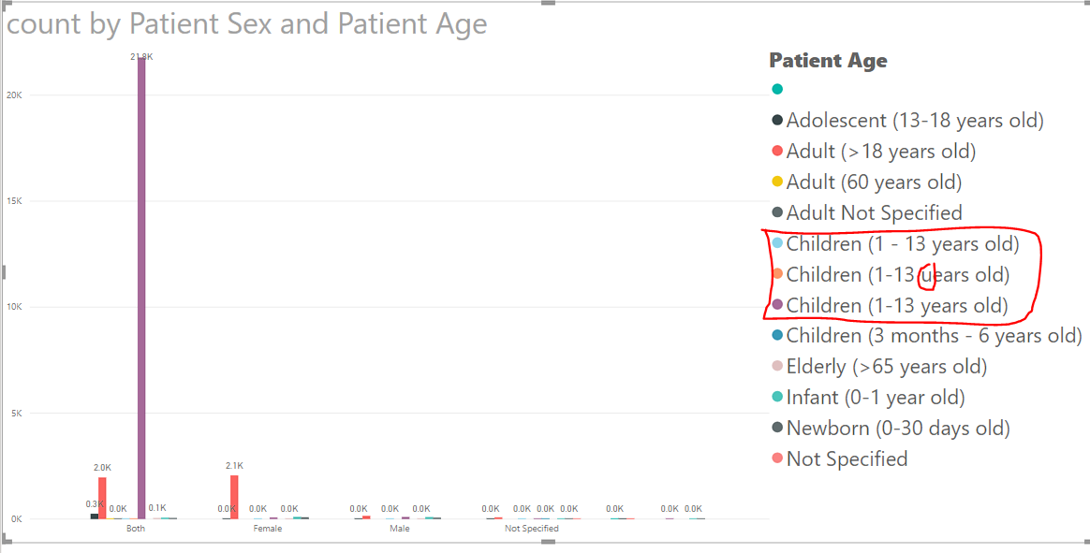

Figure Patient Sex and Age Distribution

## **Normal Concentration**

### **Subject sex and age distribution**

The majority of the subjects are adult(>18 years old) with null and both data value .The categorical value of subject sex is broad but having a little rowcount (as shown in figure 3) .thus the histogram shown below are filtered to row count greater than 100000.

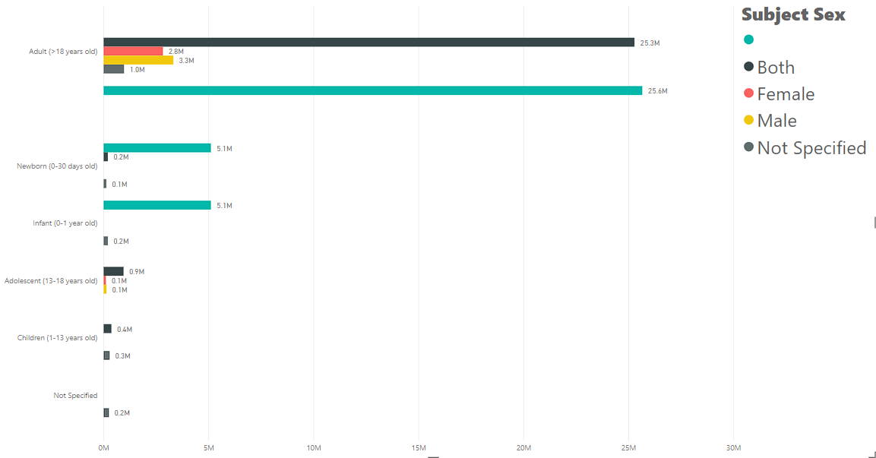

Figure Subject Sex and Age Distribution

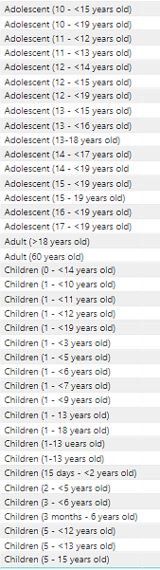

Figure Subject Age